
Name | Matric Number
Elijah She Yu Sheng
Joanne Ching Yin Xuan | A23CS0227
Lim Yu Han | A23CS0241
Lee Yin Shen | A23CS0236
Choh Jing Yi | A23CS0296
SECP2613 – SYSTEM ANALYSIS AND DESIGN
SEMESTER II 2023/2024

KADA MANAGEMENT INFORMATION SYSTEM
ANALYSIS AND PLANNING
Phases:
Project Proposal and Planning &
Information System Gathering and Requirement

Contents
1.0 Introduction 3
2.0 Information gathering process 4
2.1 Method used 4
2.2 Summary from method used 5
3.0 Background Study 7
4.0 Problem Statement 9
5.0 Proposed Solutions 11
6.0 Objectives 13
8.0 Project Planning 16
8.1 Human Resource 16
8.2 Work Breakdown Structure (WBS) 17
8.3 PERT Chart (based on WBS) 18
8.4 Gantt Chart 19
9.0 Requirement Analysis (based on AS-IS analysis 20
9.1 Current business process (scenarios, workflow) 20
9.2 Functional Requirement (input, process and output) 21
9.3 Non-functional Requirement (performance and control) 22
9.4 Logical DFD AS-IS system (Context Diagram, Diagram 0, Child) 24
10.0 Benefit and Overall Summary of Proposed System 25

1.0 Introduction

Due to the global covid-19 pandemic, there has been a shift from manual to online systems in a variety of industries, stressing the need for more convenient, safe, and efficient processes. This trend is notably noticeable in the registration system. Online registration not only ensures safety, speed, and convenience by avoiding personal interaction, but it also improves database security because the database is maintained on a highly secure server. In the contrary, information in paper form is vulnerable to multiple parties. Furthermore, online registration allows for real-time statistics updates. Organizers can access vital information, such as the number of members in the cooperative, at any time because the database is automatically updated.

One of KADA's departments is cooperatives, which are autonomous human organizations whose members join together to pursue common interests in the economic, social, and cultural spheres. It operates on numerous principles, one of which being democratic control by its members. Cooperatives are democratic organizations run by members who actively participate in policymaking and decision-making. Elected representatives are accountable to all members. The Basic Cooperative's members have equal voting rights and cooperatives at other levels are democratically constituted.

To address several problems with KADA cooperative's present manual registration process, we propose a system that moves new member registration to an online mode. Furthermore, the new system will increase membership capacity, allowing more people to benefit from the services. In addition, we will introduce an automated annual report generation tool to help management understand the cooperative's present situation.

2.0 Information gathering process

In our information collecting process, we used three key ways to acquire insights into the existing Lembaga Kemajuan Pertanian Kemubu (KADA) system. The methods are interview with KADA by having meeting, observation through website and questionnaire through Whatsapp.

2.1 Method used

First of all, we joined an industrial sharing program on 14 May 2024 through Webex platform where the KADA shared the detailed information on various aspects of their system. These information covered the topics such as the member registration process, loan application procedure, the loans available and also the calculation of the loan. Additionally, we apply the observation method by access the KADA website to get more details of the system. The website provides addition information which allow us to gain a comprehensive understanding of the current processes and procedures of the system. We also chose an unobstrusive approach of information collecting which is questionnaire, which aids in the collection of critical information on human and system requirements. For the questionnaire preparation, our group collaborated with other groups to prepare various questions, including open-ended and closed questions. By asking open-ended questions, we may go deeper into the user's requirements and find other potential issues with the current system. Then, to acquire more precise information, we conduct an questionnaire with management using closed-ended questions.

2.2 Summary from method used

We have concluded the interview with KADA management on May 14, 2024, with a summary. The goal of this sharing program is to acquire information about the background and concept of KADA cooperative. We discussed the cooperative's functioning, the types of loans they supplied, how to apply for a loan, how the loan gets authorized, what the repayment rate is, and so on. As a result of this meeting, we decided to present an online system for KADA cooperative that focuses on two major modules which are member registration and loans. In addition, we conducted an observation on the KADA cooperative's current website. The aim of this observation is to examine the workflow efficiency and identify any problems on the website. We discover that the website's navigation is challenging and the user struggles to understand how to use the system. Aside from this, the system lacks clarity. There are no clear instructions on how to apply for benefits; they merely supply a form and do not indicate any subsequent actions. We also noticed a delayed load time during our observation. For the questionnaire, our group prepared two questions for the surveyor. This questionnaire session allowed us to gain a better understanding of the client's system requirements. The client also provided some further clarifications on our idea.

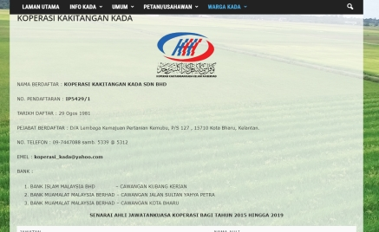

Figure 2.2.1 Current website of KADA cooperative

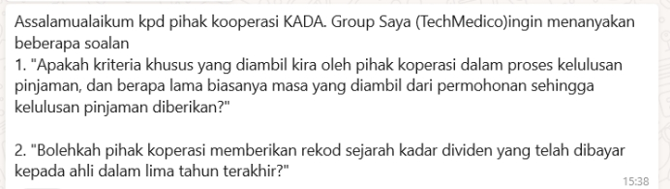

Figure 2.2.2 Example of the questions from our group

3.0 Background Study

Lembaga Kemajuan Pertanian Kemubu(KADA) is an agency under the Ministry of Agriculture and Food Security, established on March 30, 1972, under Section 4 (1) of Act 69, the Kemubu Agricultural Development Authority Act 1972, Lembaga Kemajuan Pertanian Kemubu (KADA) is an agency under the Ministry of Agriculture and Food Security. On March 2, 1973, YAB Tun Hj Abdul Razak Bin Hussein, the second prime minister of Malaysia, officially created it. KADA is a leading organization dedicated to improving the economic status of farmers and increasing the country's food production, especially in rice and paddy to fulfill domestic needs. To bring farmers' per capita earnings into line with national statistics, it seeks to help agricultural families. Additionally, KADA works to enhance agriculture in the Kemubu region and builds and strengthens farmer institutions.
KADA offers a wide range of services,we going to focus on cooperatives section that KADA held to open an investment space for the members registered under it.KADA offers its members that registered under the cooperative a variety of financial benefits,including investment such as “Modal Syer” and “Modal Yuran” ,loans to support personal and business needs.The are five main loan plan for member registered under it which are “Pinjaman Al Bai”, “Pinjaman Al Innah”, “Pinjaman skim khas”, “Pinjaman road tax and insurance” and “Pinjaman Al qardhul Hasan”In order to help members safely plan for the future, KADA also provides a savings plan created especially for retirement funds. These all services are designed to support members' financial development and stability, promoting a community of financially independent people.
Lembaga Kemajuan Pertanian Kemubu (KADA) cooperative(koperasi) will include service like investment,saving plan for retirement fund and a loan facility.Employees can apply for membership in this cooperative by paying a registration fee of RM 55 and investing RM 300 in unit shares. So with a total of RM 355 to become a member.Members can acquire shares for RM300, which may be paid in lump sum or monthly salary deductions, with RM50 deducted over six months and an additional RM5 as a contribution to the member welfare fund.As required by the Malaysian Cooperative Commission, members must pay their share, up to a maximum of RM10,000, in order to qualify for loans. For membership fees, there is a minimum payment of RM35.KADA also differentiates between share capital, which is required for loan eligibility, and savings, which serve different purposes.
The system will not be able to allow the general public to join its cooperative membership through the system. Membership is limited to those who register and fulfill the particular requirements established by KADA. Furthermore, KADA does not provide membership cards to members who have successfully registered as members. Serving registered members with perks and services designed only for them continues to be the major priority.
There is also many benefits to be involved in KADA cooperative.offers the benefits which include a savings plan for retirement, with an annual dividend of approximately 4.2% on the shares. Additionally, members can apply for loans up to RM 20,000.Besides,member welfare fund supports member welfare activities including Hajj and Umrah payment, death benefits for members and their spouses, and other member welfare programmed. In order to help members after retirement and ensure their financial stability and future demands are met, fixed savings plans are also offered.

4.0 Problem Statement

The cooperative (koperasi) run by Lembaga Kemajuan Pertanian Kemubu (KADA) offers significant benefits to its employees, such as loans and a retirement fund. However, a cumbersome manual registration procedure and a restrictive membership limit are the cooperative's two main problems, which restrict its efficiency and accessibility.
At this point, employees must fill out a manual form to register as a member of the KADA cooperative. This outdated method is hard to use and results in a lot of mistakes and inefficiency Employees have to complete paper forms, which can be cumbersome and error-prone. Employees are discouraged from enrolling by this cumbersome process as they may think it is too complex or inconvenient. Additionally, the registration form can only be found in Malay, which presents a major problem in increasing the number of employees registered under the cooperative. This is because they might be some employees do not know the Malay language well. The cooperative's reach is restricted by this linguistic barrier, which also decreases the benefits of KADA's diversity and accessibility.
Apart from the registration process which is cumbersome, there is a 500 members cap on the cooperative at the moment. This restriction significantly limits the number of employees who may register as a member of the cooperatives. Many potential employees are unable to join and benefit from the cooperative's financial advantages since the workforce exceeds the membership the limit. Due to this restriction, KADA's employees is unable to take advantage of important loan activities and retirement savings plans that might improve their well-being and financial stability. The membership cap impacts not just the options available to individuals but also the cooperative's ability to develop and have an influence.
The third main problem that KADA cooperative must overcome is the lack of month-end and year-end financial reports, which include profit and loss statements. Because members are unable to monitor the cooperative's financial status or the management of their contributions, the lack of financial transparency affects member confidence and involvement.Improving the cooperative's efficiency, dependability, and attraction for current and new members will involve solving this issue.
These issues have wide-ranging consequences.inefficiencies of the manual registration procedure,number of members restriction and system that doesn’t has a summary report inhibit employees from joining the cooperative. As a result, the cooperative's membership decreases and clients' general satisfaction with its services declines. Due to the difficulty and barrier to registration, employees who may profit from the cooperative's financial goods may be left out. Furthermore, this problem is made worse by the membership cap, which keeps many motivated employees from taking part, missing out on opportunities for money, and decreasing productivity. The cooperative's limited capacity to provide services to a larger portion of KADA's workforce reduces its chances for development and lowers its efficacy as a financial assistance system for employees.

5.0 Proposed Solutions

The present manual registration method has issues that the e-registration system was created to solve this problem. Every operation and information in this system is computerized. It's essential to take into consideration the feasibility of the proposed system which are operational, technological, and financial aspects in order to solve the difficulties the KADA cooperative is facing and provide an achievable solution.
Operation Feasibility: Our suggestion is to change from a manual registration procedure to an online automated method to make it simpler and quicker. The current system is prone to errors and inefficient, as it requires physical forms.We suggest that the system can mainly using drop down box to provide selection for the register members so that users do not need to enter all the information on their own. This can reduce the chance of typos and make the Data Mining process. We also suggest that the registration form should also be provided in Chinese, English, and Malay. In order to enable more employees to join, we suggest increasing the membership limit from 500 to a larger figure. This requires altering methods to efficiently handle additional members by establishing a offer of multilingual guidance in the registration.Other than that is enhanced the financial reporting to evaluate the cooperative's financial situation, particularly its profit or loss. Transparency and accountability within the cooperative will be promoted by making financial reports available to members via the web system.

Technical Feasibility: Creating a secure online platform is crucial. This platform need to support several languages and interface with KADA's current systems. Besides,financial information and member privacy will be ensured by using secure authentication and robust encryption to ensure data security and privacy.In Software-wise, Microsoft Word will be used for financial reporting, making it possible to create and handle thorough financial documentation. The user interface will be designed and prototyped using Figma.Windows 10 as the operating system
, guaranteeing an intuitive and effective platformIn term of hardware,for the system to function effectively, laptops with a minimum of specifications are needed.These specifications for hardware will guarantee that the platform operates at peak efficiency, enabling the several features required to efficiently service KADA's members. These hardware and software elements working together will provide a reliable and secure system that satisfies the requirements of the cooperative.

Economical Feasibility(CBA):

6.0 Objectives

Objectives for the Project Proposal

1. Enhance Membership Accessibility
- To evaluate the feasibility of opening Koperasi KADA membership to the general public, thereby expanding the cooperative's reach and potential membership base.

2. Digitize Board Meetings
- To propose and assess the implementation of a digital system for Board of Directors meetings, aimed at improving efficiency, record-keeping, and accessibility for all board members.

3. Streamline Membership and Loan Approval Processes
- To review and improve the current manual processes for membership and loan approvals to ensure faster processing times and better member satisfaction.

4. Implement Effective Communication Channels
- To establish more effective communication channels between the cooperative and its members, ensuring that all members are well-informed about their rights, benefits, and any changes in cooperative policies.

5. Introduce Online Application System
- To explore the possibility of introducing an online application system for membership and loans to increase accessibility and streamline the application process.
7.0 Scope of the Project

Project Scope Statement

The objective of this project is to modernize key aspects of Koperasi KADA's operations to improve accessibility, efficiency, and member satisfaction. The project will primarily focus on enhancing membership accessibility, digitizing board meetings, streamlining membership and loan approval processes, implementing effective communication channels, and introducing an online application system.

Scope
--------
1. Enhanced Membership Accessibility
- Evaluation of the feasibility of opening membership to the general public.
- Development of criteria and processes for onboarding new members from the public.

2. Digitized Board Meetings
- Proposal and assessment of a digital system for Board of Directors meetings.
- Implementation of the digital system to improve efficiency and accessibility.

3. Streamlined Membership and Loan Approval Processes
- Review and improvement of manual processes for membership and loan approvals.
- Implementation of streamlined, partially or fully automated processes for faster approvals.

4. Effective Communication Channels
- Establishment of more effective communication channels between the cooperative and its members.
- Ensuring all members are well-informed about their rights, benefits, and policy changes.

5. Online Application System
- Exploration of the possibility of introducing an online application system for membership and loans.
- Development and implementation of an online application system to increase accessibility and streamline processes.

Introduction/Background to Project
Koperasi KADA has recognized the need to modernize its operations to better serve its members and remain competitive in the market. The project aims to address key areas such as membership accessibility, board meeting efficiency, process streamlining, communication effectiveness, and online service delivery to meet the evolving needs of its members and enhance overall organizational effectiveness.

Deliverables
1. Feasibility report on opening membership to the general public.
2. Digital system proposal and assessment for board meetings.
3. Improved manual processes for membership and loan approvals.
4. Established effective communication channels between the cooperative and its members.
5. Online application system developed and implemented for membership and loans.

8.0 Project Planning

8.1 Human Resource
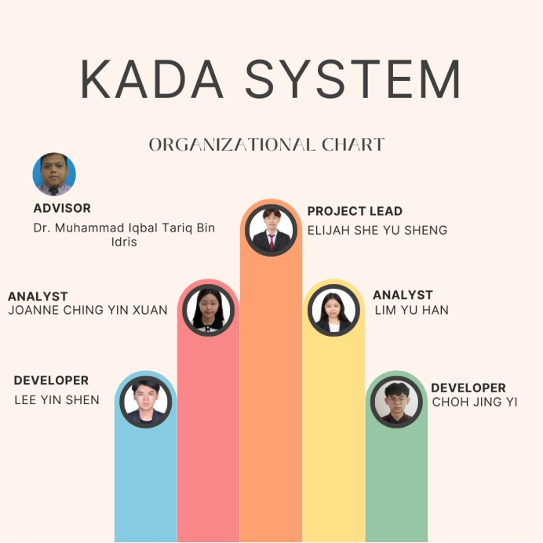

8.2 Work Breakdown Structure (WBS)

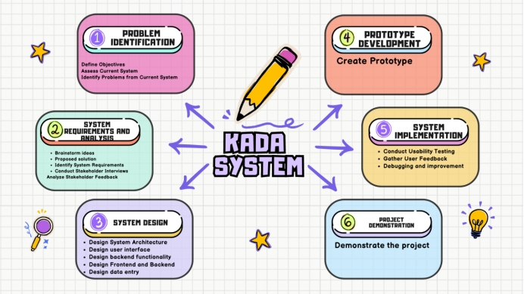

8.3 PERT Chart (based on WBS)

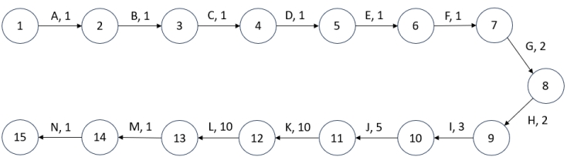
Pert Diagram
Activity |  | Duration (days)
A | Interview | 1
B | Assess Current System | 1
C | Identify Problems from Current System | 1
D | Propose solutions | 1
E | Propose scope & limitation | 1
F | Propose system requirement | 1
G | Create flow chart | 2
H | Create Pert & Gantt chart | 2
I | Create Context, Zero and Child Diagram | 3
J | Design user interface | 5
K | Design function structure | 10
L | Create prototype | 10
M | Debug and improve system | 1
N | Demonstrate project | 1
Path: A-B-C-D-E-F-G-H-I-J-K-L-M-N
Length: 1+1+1+1+1+1+2+2+3+5+10+10+1+1
Total duration: 40 days

8.4 Gantt Chart
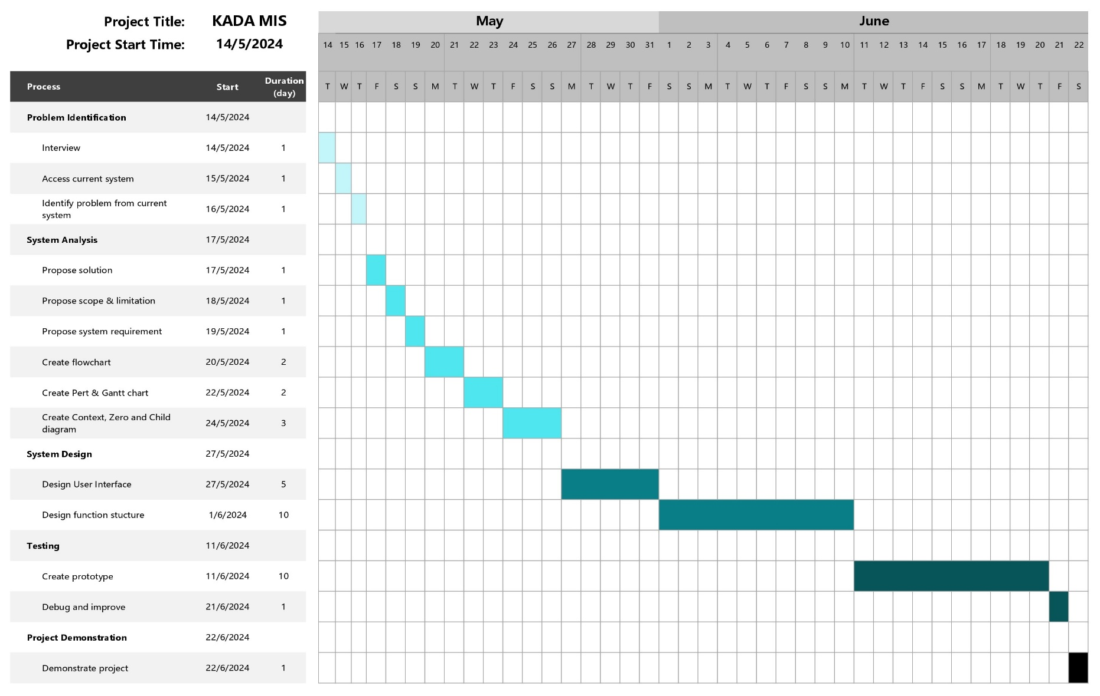

9.0 Requirement Analysis (based on AS-IS analysis

9.1 Current business process (scenarios, workflow)

9.2 Functional Requirement (input, process and output)

9.3 Non-functional Requirement (performance and control)

Performance Requirements
1. Response Time: All user activities, including form submissions and data retrieval, should be handled by the system in a smooth manner by guaranteeing a response time of no more than two seconds. Its prompt reaction time is crucial to avoiding user annoyance and ensuring productivity during peak use times.

2. Scalability: The system should be able to handle more users and data volume without experiencing a noticeable decrease in performance. This involves the capacity to grow both horizontally by adding more servers and vertically by adding more hardware resources.

- Throughput: During peak hours, the system need to be built to manage at least 500 registration request and application submission every hour. High throughput guarantees that the system can remains responsive and accessible to all users,especially during enrollment times, and process huge amounts of data effectively.

Control Requirements
- Security: The system must be secure by implementing multi-factor authentication for user verification and role-based access control to limit access to personal information. Furthermore, to guard against unauthorised access and data breaches, all financial and personal data must be protected using industry-standard encryption techniques while it is in transit and at rest.

- Maintainability: The system should be designed with high maintainability, ensuring that it can be restored to operational status quickly and efficiently after a failure. This involves a modular architecture that allows individual components to be easily updated or replaced without affecting the entire system. Comprehensive documentation, including user manuals, technical guides, and API documentation, must be provided to support efficient maintenance and user training.

3. Auditability: The system should maintain comprehensive logs of user activities, system events, and changes made to data or configurations. These logs enable administrators to track and analyze system behavior for troubleshooting, compliance, and forensic purposes.

9.4 Logical DFD AS-IS system (Context Diagram, Diagram 0, Child)

10.0 Benefit and Overall Summary of Proposed System

KADA.gov.my is a system that we proposed to address the inefficiencies and limitations of the current manual registration process. The system will automate procedures by moving to a digital platform, significantly reducing down on processing time and human error. The implementation of this modification will enable instantaneous changes to the database, guaranteeing that the data is consistently up to date and precise. The system will also support several languages, allowing employees to register and apply for loans from anywhere at any time, and making it accessible to a the applicants.

Besides that, the new system's improved security features are one of its main advantages. The digital platform will protect sensitive financial and personal data more effectively than paper-based solutions by utilising strong encryption and secure authentication procedures. The centralized database, maintained on a highly secure server, will minimize the risk of data breaches. Additionally, the scalability of the system will enable an increase in membership capacity, allowing more workers to sign up and take advantage of the cooperative's services at the same time without experiencing a fall in performance.

Overall, the new online registration system will significantly improve member satisfaction by simplifying the registration and loan application processes. Real-time data and automated yearly report compilation will give management timely insights to support strategic decision-making and effective cooperative management. The organization's objective of raising the socioeconomic standing of farmers in the Kemubu region will ultimately be supported by this modernization initiative, which will also guarantee that KADA's cooperative is safe, secure, and responsive to the demands of its members.

